**Relative humidity: It is the amount of water in the air at a given temperature expressed as a percentage of the amount of water the air could hold.**

**The dew point is the temperature to which air must be cooled to become saturated with water vapor. When cooled further, the airborne water vapor will condense to form liquid water (dew). When air cools to its dew point through contact with a surface that is colder than the air, water will condense on the surface.**

**Psychrometer Data:**

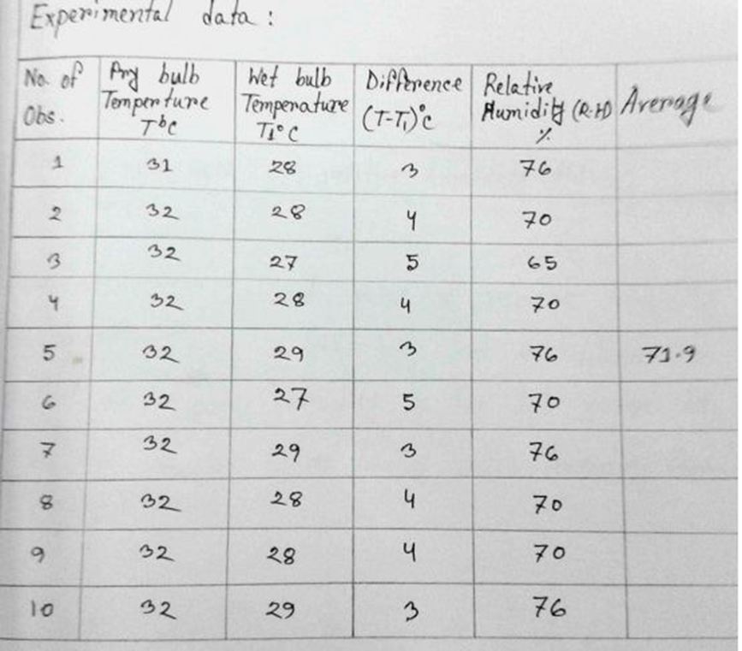

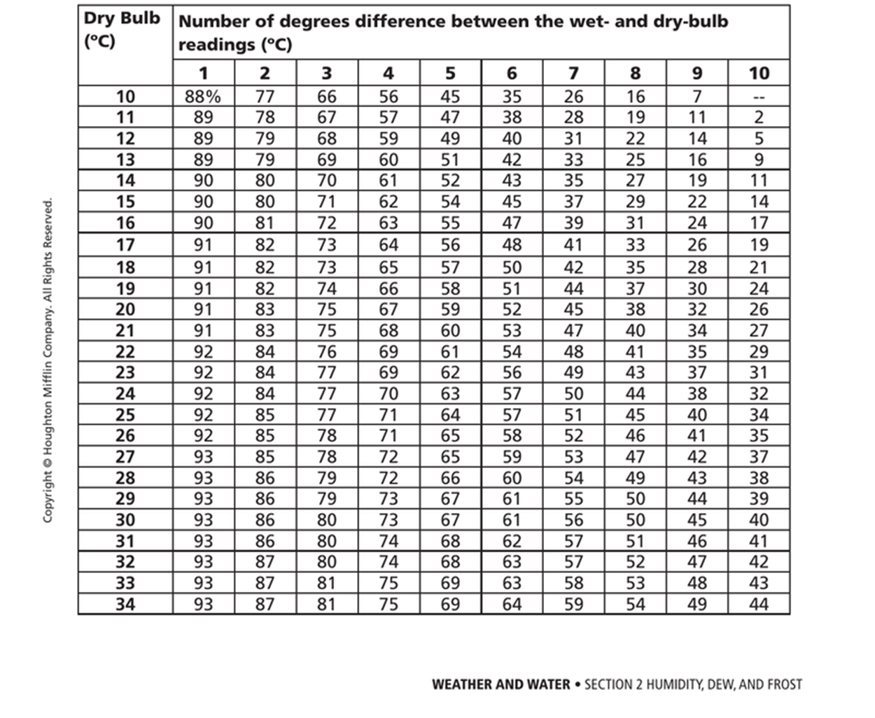**Relative Humidity Chart:**

**Dew Point:**

